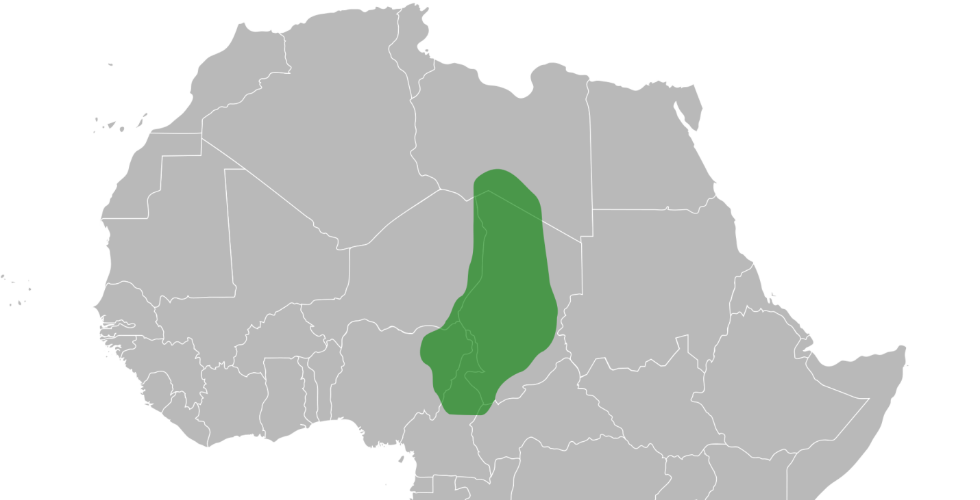
Also known as the Kanem Empire

Location: Kanem was an empire in Central Africa. It controlled trade around Lake Chad. Its territories included parts of modern Chad, Cameroon, Nigeria, Niger, and Libya.
Time Period: The Kingdom of Kanem reigned from the 800s to the 1800s.
Trade/Economy: Kanem handled trade between North Africa and lands to the south. The empire sold such products as salt, ivory, ostrich feathers, and live animals. Imports included salt, horses, silks, glass, and copper. The empire also traded slaves to people in North Africa in exchange for war horses. The Kanem people raised crops and livestock for their own use.
Religion: Early Kanem people believed in many gods. In year 1000, a Sef king became the first Muslim king in Kanem. From that time on Kanem was a Muslim state.
Culture: The Kanem was the strongest of the empires formed in Chad. The empire was founded by the Zaghawa people, who may have been the first in the region to acquire and make use of iron technology and horses.
Early Kanem people were nomadic, they traveled from place to place. In the 8th-century a Sef king established a capital city and people settled there. The Sef family brought great changes to Kanem. In the 11th-century, the kingdom converted to Islam. Kanem was able to take advantage of new ideas from Arabia and from the Mediterranean area. Islam also brought better education.
Kanem’s kings travelled often throughout the kingdom. The farmers acknowledged their allegiance to the kingdom by paying taxes and hosting the king.
The Kanem Empire was militaristic and believed in expanding their territory through conquest. Fathers would pass down their military rank to their sons. They rode horses into battle, and they fought many wars. However, these wars eventually led to the empire's decline.
Famous Ruler: Idris Aluma (or Alooma) is remembered as the greatest Kanem king. He was known for his military skills, new laws, and Islamic belief. One epic poem claims that he won 330 wars and more than 1,000 battles. His innovations included fixed military camps and "scorched earth" tactics, where soldiers burned everything in their path.
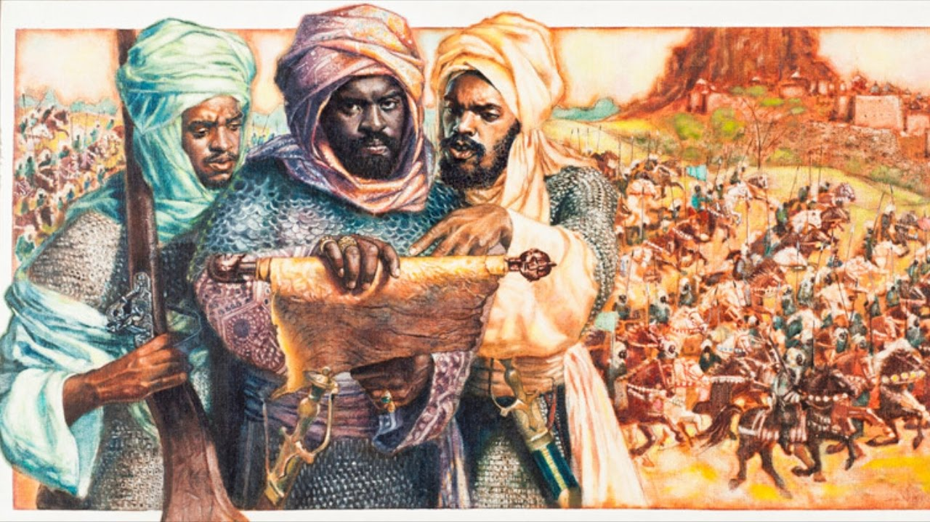
Aluma introduced a number of laws based on his religious beliefs. He sponsored the construction of numerous mosques and made a pilgrimage to Mecca (hajj).
Kanem under Aluma was strong and wealthy. Aluma took a greater interest in trade and other economic matters. He is credited with having the roads cleared, designing better boats for Lake Chad, introducing standard units of measure for grain, and moving farmers into new lands. In addition, he improved the security of travel through the kingdom with the goal of making it so safe that he took pride in saying that a woman had only God to fear if she walked the streets alone, even if she was wearing gold.
The empire declined after the death of Idris Aluma.

