Let's Make Lemonade
Name: Chef ___________________ Date: ________________

Ingredients

sugar

1 cup _____________

lemons

6-8 _______________

water

6 cups ____________

Recipe
Sequence Word Recipe Verb

______, ________ the lemons in half.

______, ________ the lemons for juice.

______, ________ the sugar, lemon juice, and water with a measuring cup.

_____, _________ the sugar, lemon juice, and water in a pitcher. Enjoy!
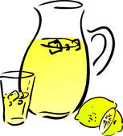
Recipe Verbs:
squeeze mix
cut measure
Sequence Words:
Then Next
First Finally

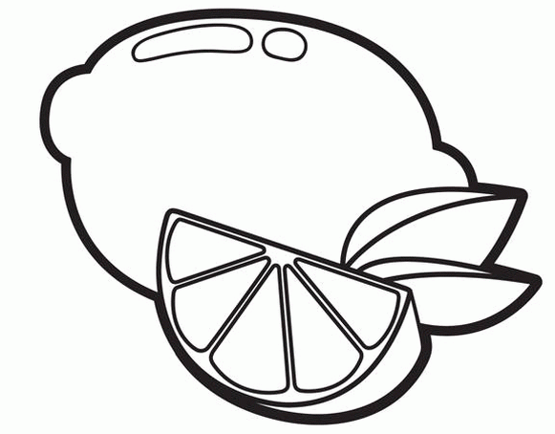
Ingredients:
Recipe:
First,
Then,
Next,
Finally,

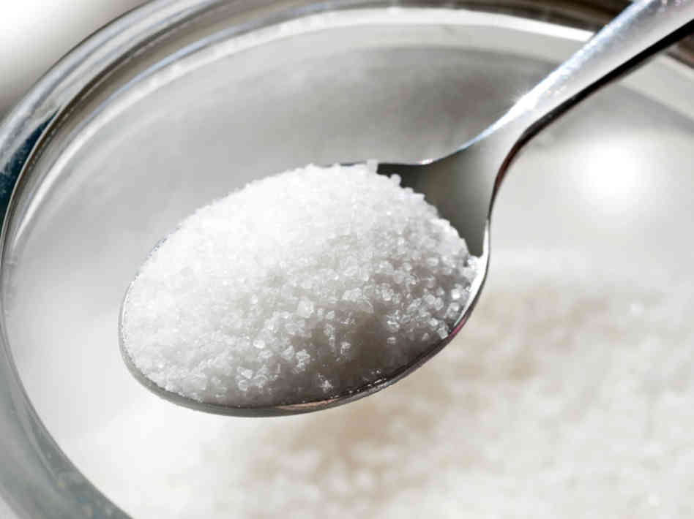
to cover the words on page2

