Instructor Copy
Oh the Places You'll Go and the Words You'll Make! 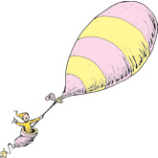

Directions: Cut apart the letters at the bottom of the page. (The lines go on the bottom of each card!) Then try to make as many words as you can. Write the words in the correct column. Can you find the secret word that uses all of the letters?

2 letter words 3 letter words 4 letter words 5 letter words 6-9 letter words
to  do  us  or | toe  dot, rot  use  ore  red  out  due, sue, rue | toes, does  dots, rots, dote  uses, ruse  ores, sore, tore  reed, seed, rest  oust, tour, sour  dust, rust, rest | dotes  store  reeds, seeds  roust, route  duster, rusted | stored  rested  rousted  tuxedo  extrude(s)

Write the secret word here: DEXTEROUS- Synonyms: clever, skilled, adroit

e e t x u s o d r

