Name: ____________________________
Oh the Places You'll Go and the Words You'll Make! 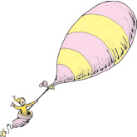

Directions: Cut apart the letters at the bottom of the page. (The lines go on the bottom of each card!) Then try to make as many words as you can. Write the words in the correct column. Can you find the secret word that uses all of the letters?

2 letter words 3 letter words 4 letter words 5 letter words 6-9 letter words

Write the secret word here: _____________________________

e e t x u s o d r

