The manor system, also called manorialism, is the political, economic, and social system of medieval Europe. Its basic unit was the manor, an estate that was under the control of a lord who ruled over his serfs.
The manor system organized the estates of the nobles and the clergy in the Middle Ages in Europe, and it made feudalism possible. The manor system was used in France, England, Germany, Italy, Russia, Japan, and Spain.

Protection: To protect themselves, local warlords built castles. They also depended on warriors on horseback called knights. Wealthy lords used the manor system to protect their lands from invading armies. Because of the danger, many small farmers exchanged their land or their freedom for the protection of powerful lords. These lords had the military strength to defend them from invaders. Some lords built large stone homes with military defenses known as castles. A serf would receive a home and protection in exchange for their labor and loyalty.

Organization: The typical European manor in the 13th-century consisted partly of the cottages, huts, barns, and gardens of its serfs, which were usually close together to form a small village. There might also be a church, a mill, and a wine press in the village.
The village was surrounded by arable land that was divided into three large fields that were farmed in rotation. There were also usually meadows for supplying hay, pastures for livestock, streams for fishing, and forests for wood-gathering and hunting.
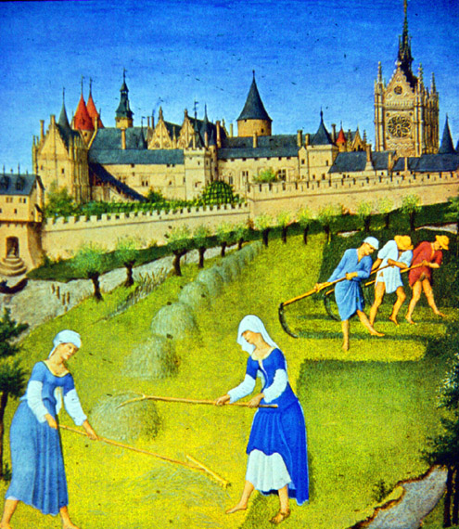
Serfs: A serf was not free; he could not without leave his job on the manor, and he could be punished by the law if he did. However, serfs were not slaves. They could not be bought or sold, but they did owe lifelong service to their lord. It was possible for a serf to purchase his own freedom, but it was rare.
The life of a serf was difficult. Week by week, a serf was required to come with his own plow and oxen to farm the lord’s land. It is often said that a serf was, “tied to the land”. A serf also had to pay a high rent for his home.

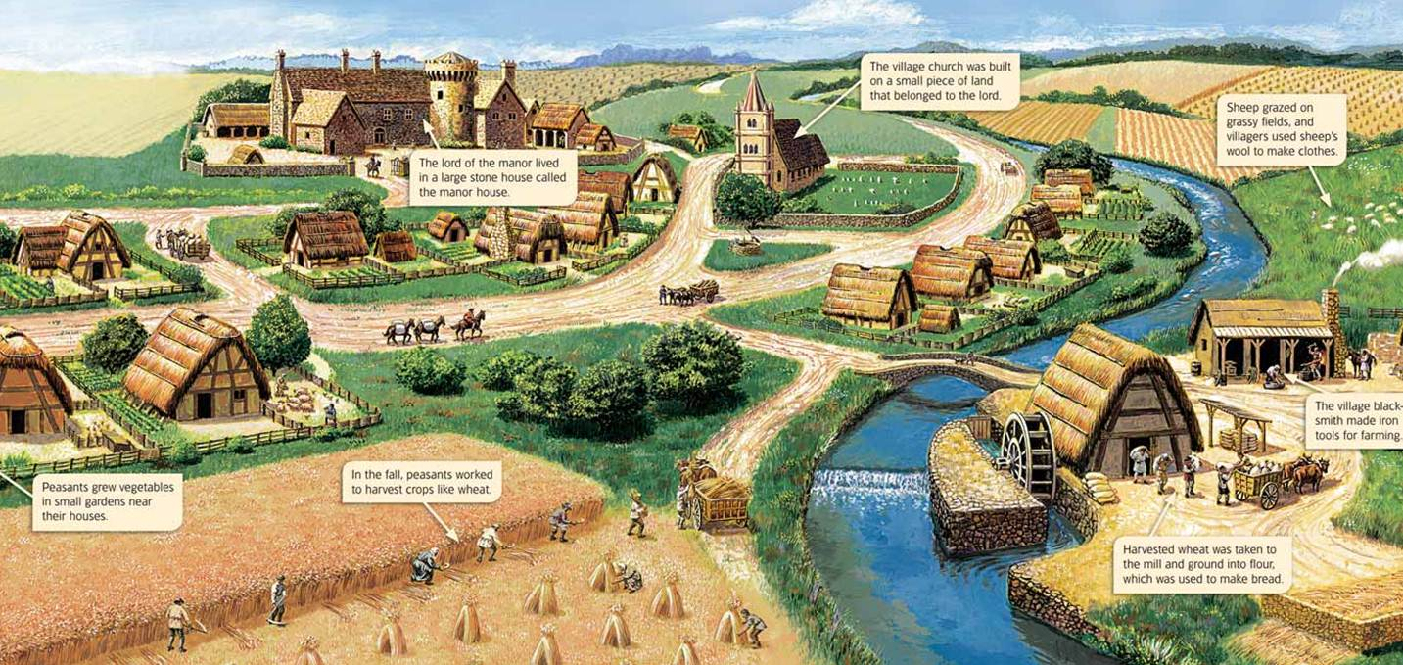
Decline: The manor system could only survive when the central government was weak. In the 13th-century governments became more stable, and money became important as towns grew and markets thrived. Lords began to allow their serfs to work in towns, where they could make more money for the lord. Many serfs were able to purchase their freedom from their lords. This lead to the decline of the manor system.
By the 14th-century CE, the manor system had almost completely disappeared. However, traces of the manor system stayed on in Europe for
hundreds of years. Peasants in France owed duties to their lords until the French Revolution, in 1789. In Russia the serfs did not gain freedom until 1861.

