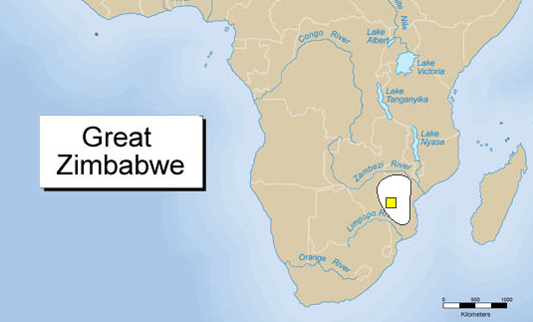
Also known as Great Zimbabwe

Location: The kingdom of Zimbabwe was located along the coast of modern Mozambique in Southern Africa with ports along the Indian Ocean.
Time Period: The kingdom began around 400 CE and reached its height in the 14th and 15th-centuries.
Trade/Economy: Great Zimbabwe came from a prosperous farming community and became the center of a thriving trading state. Agriculture and cattle were vital to the economy, but the state also became increasingly involved in the mining of gold, which was traded at ports on the Indian Ocean.
Discoveries of Chinese porcelain, engraved glass from the Middle East, and metal ornaments from West Africa provide evidence that Great Zimbabwe participated in a wide trade network during the 13th and 14th centuries. From the tax on trade, the kings of Zimbabwe lived in luxury, surrounded by gold, copper, and exotic imports such as beads, porcelain, and cloth, from China, Persia, and India.
Religion: The people of Great Zimbabwe most likely worshipped Mwari, the supreme god in the Shona religion. Religion played a very important role in the rise of Great Zimbabwe as a political center. Religion kept people together in the kingdom because they believed that the rulers were believed to be holy. There are many frightening myths and legends about the king’s extraordinary powers.
Culture: The first inhabitants of Great Zimbabwe were Shona peoples who likely settled in the region as early as 400 C.E. Back then, the land was full of possibilities: fertile soil to support farming and mineral rich territories to provide gold, iron, copper, and tin for trading and crafting. It was fine place for the Shona to call home.
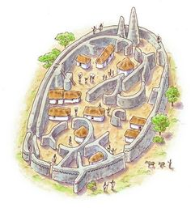
By 1000 C.E., the population of Great Zimbabwe was divided and ranked by social class— from elite leaders to the peasants who did all the work. The leaders lived inside a walled community made of stone. It was the dividing line between the rich and the rest. The largest and most impressive building is known today as the Great Enclosure.
The remains of its wall measure over 800 feet long and up to 32 feet high. The wall enclosed several huts and a tall, cone-shaped tower. The name Zimbabwe is a Shona word meaning “stone houses.”

