The Kingdoms of Aksum and Benin
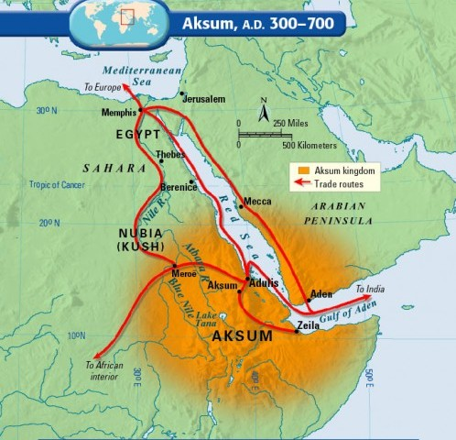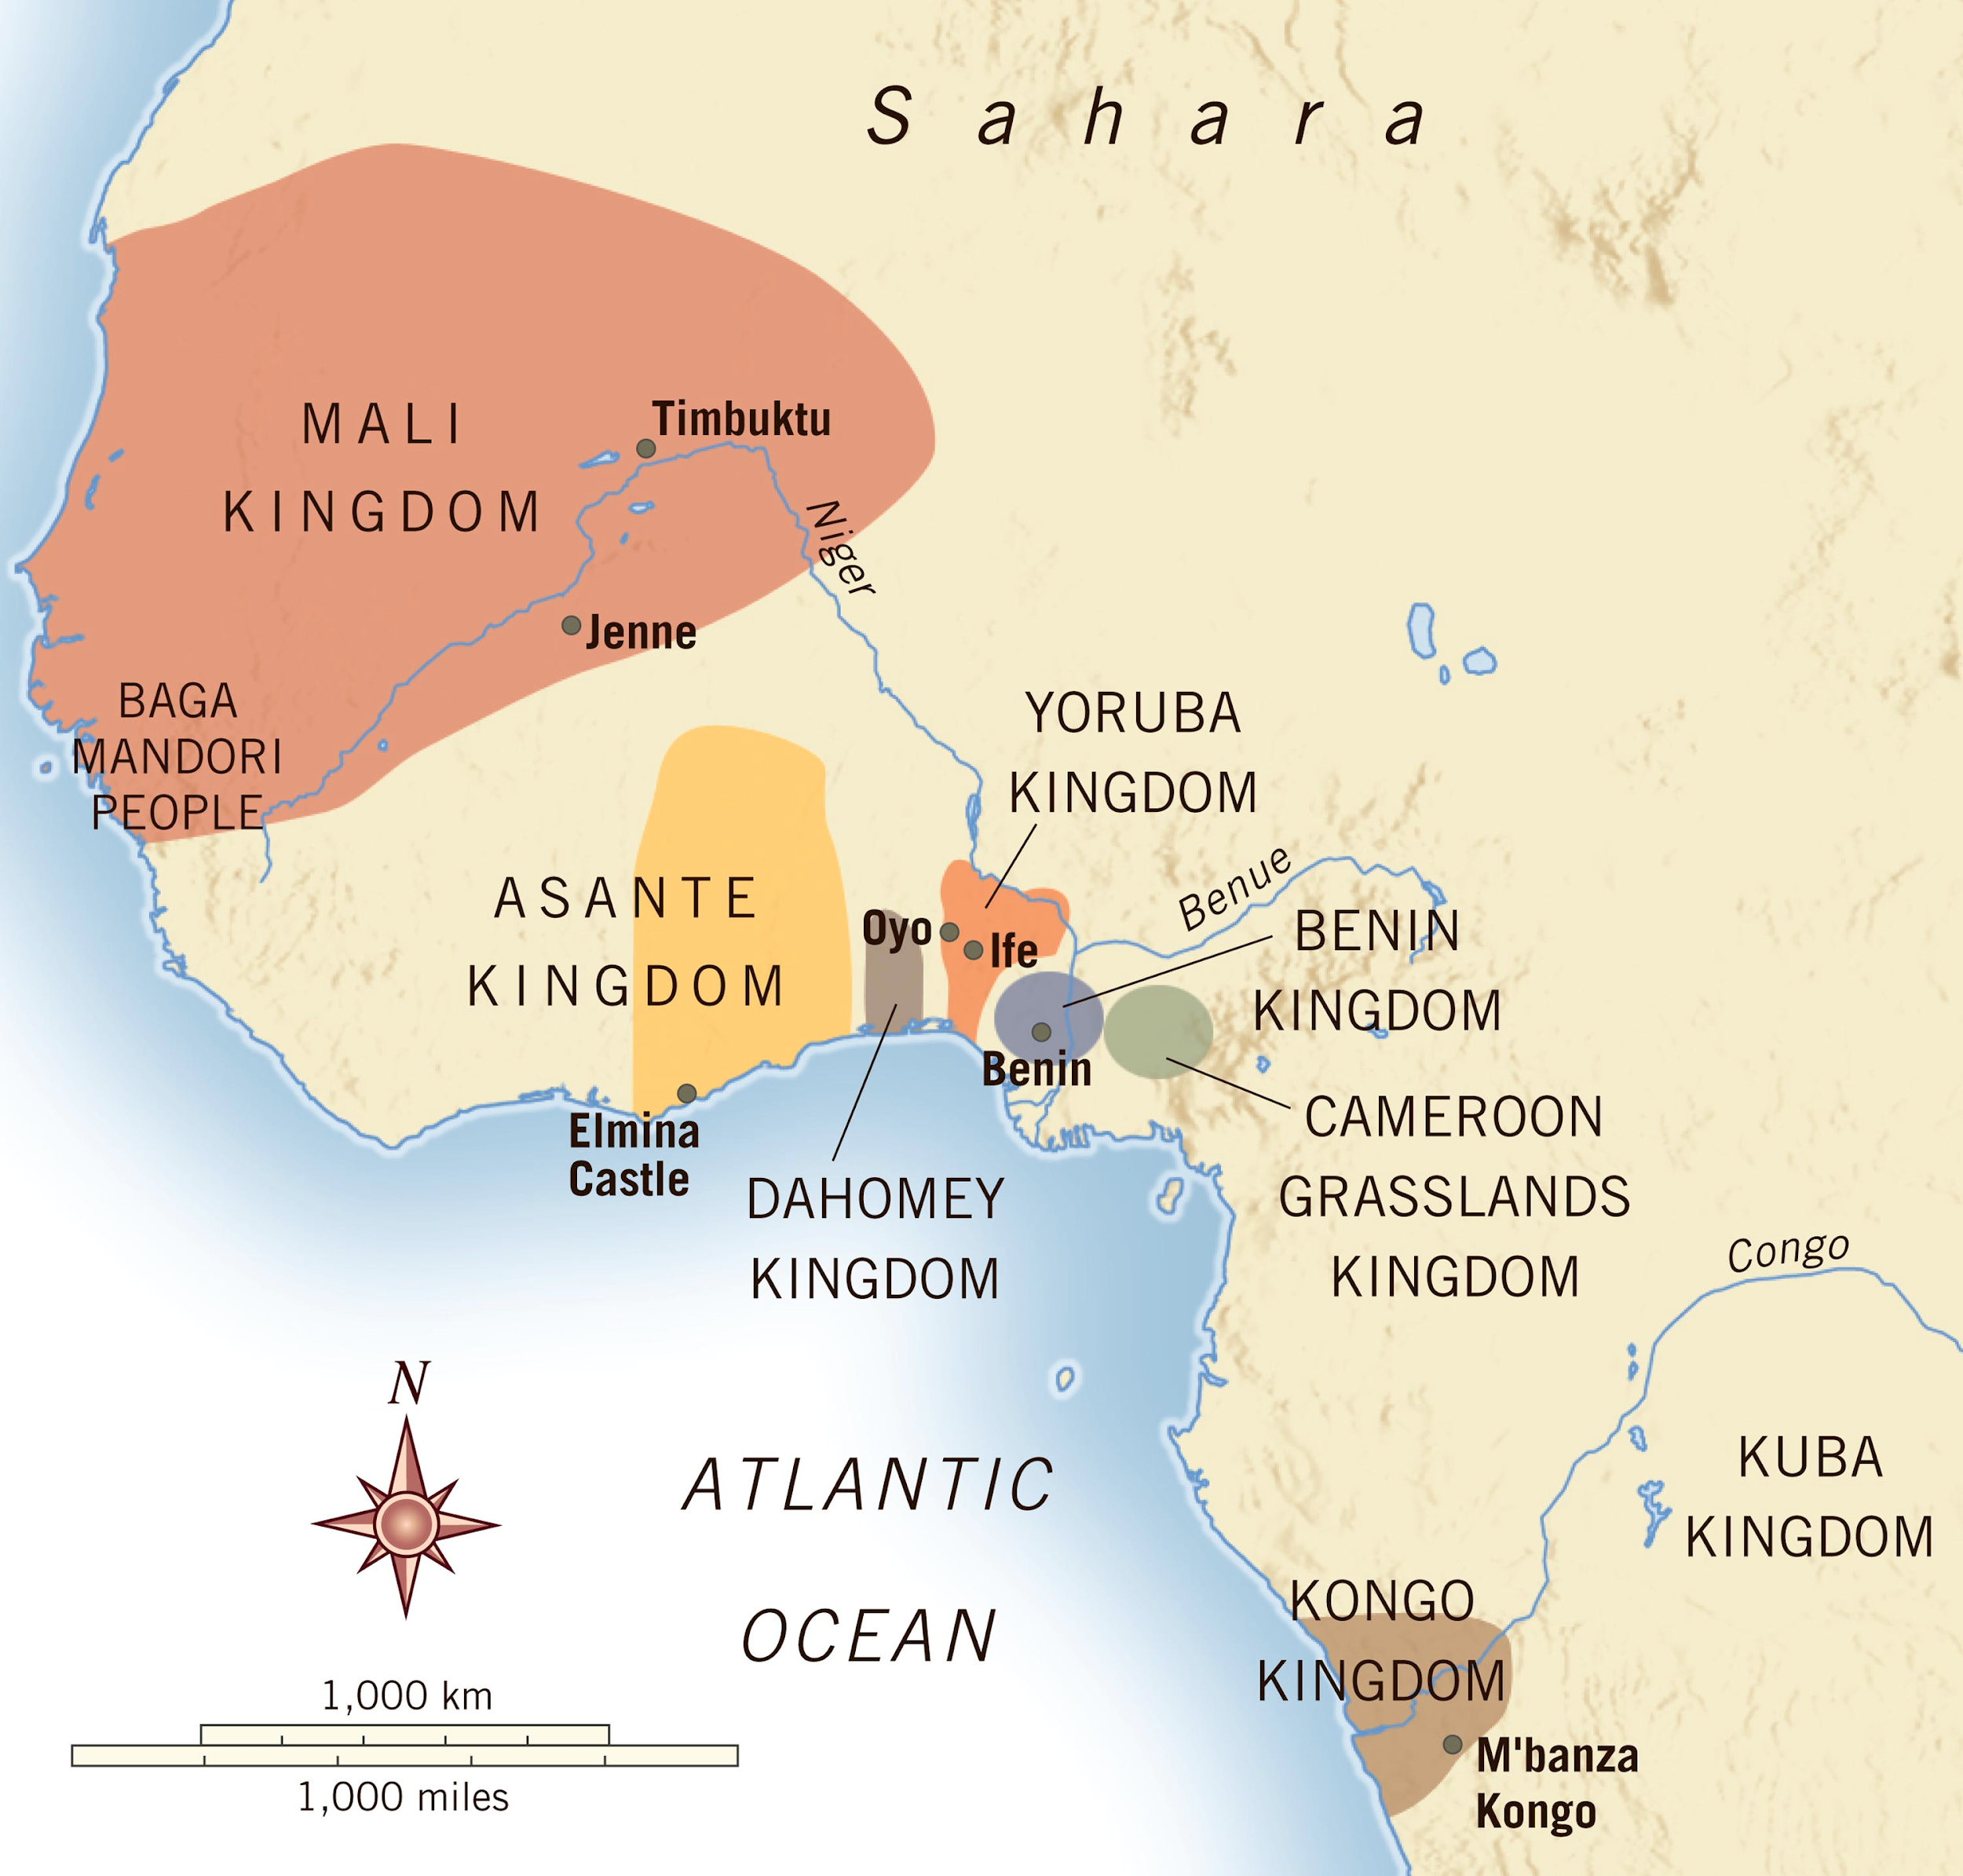
Though Benin and Aksum were both African (1)___________, there were many differences (2)__________ them. Both Benin and Aksum grew along (3)___________. Though the Benin people followed the Niger and the Aksum people followed the (4)___________ and the Red Sea. For both kingdoms, their (5)___________ gave them great wealth. The Aksum traded iron, gold, and (6)_________, while the Benin traded ivory, pepper, and palm oil. Benin was located near (7)____________ and used the timber to build homes and create art objects such as wooden masks and statues. On the other hand, wood was (8)_________in the Aksum kingdom, making it difficult for them to make the fires they needed to smelt their iron. Unlike the Benin, the Aksum needed (9)__________ to survive. The wealth of both kingdoms belonged primarily to the (10)__________ families. Benin believed that their kings were divines, descended from gods. However, Aksum people became (11)__________in the 3rd-century and stopped believing in divine kings. In Benin, nobles were responsible for (12)_______________ the history of their people. There was no (13)____________ language in Benin. They paid artists to create objects that would help them (14)__________ their people's stories and histories. In contrast, the nobles of Aksum could often (15)__________ and write, and they used long stones and books to record their histories. The Aksum borrowed this tradition from their Egyptian and Kush neighbors to the north. In both kingdoms, the everyday people were (16)_________. These differences between Benin and Aksum are (17)___________ because they demonstrate the variety of (18)____________ of people throughout Africa.

