The Mali Empire
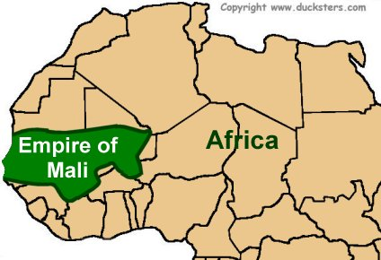
The great empire known as Mali thrived in West Africa from the 1200s to the 1500s. It grew from a small kingdom called Kangaba on the Niger River to a vast area that included some of the most important trading regions of the time. Trading and gold mining made Mali rich.
Mali was a kingdom of the Malinke people. The founder was named Sundiata. His empire grew rapidly.
During the Mali Empire, salt was worth as much as gold. Mali had plenty of gold but no natural salt. Human bodies need salt, and salt is also useful to preserve food. Mali set up a gold-salt trading network that made them one of the wealthiest empires in the world.
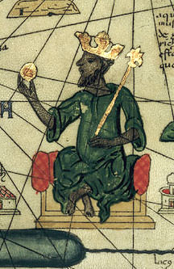
The most famous Mali emperor was Mansa Musa. He came to the throne in about 1307. Musa was a Muslim, even though many of his people worshipped traditional gods. His grand pilgrimage (hajj) in 1324 to the holy city of Mecca made Mali famous. It was said that he brought with him 60,000 richly dressed followers and slaves. It was also said that each one of the 80 camels in his caravan carried 300 pounds of gold.
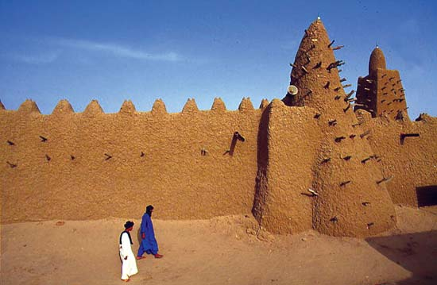
Musa added the trading cities of Timbuktu and Gao to his empire. He ordered many buildings to be built in these cities and other places. Some of these buildings were mosques. A university in Timbuktu had its beginnings during Musa’s reign.
The empire began to decline in the 1400s. Some of the cities rebelled against their Mali rulers, and others were attacked by neighboring people. By 1550 Mali had lost most of its power. The name Mali lives on today in the modern country of Mali.
The Ghana Empire
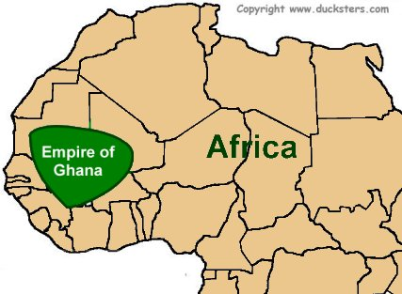
The Ghana Empire was the best known and most powerful of the medieval trading empires in West Africa. Led by Mande-speaking peoples, the empire took its name from the Mande word for “warrior king.” Ancient Ghana was located an area that is now part of Mali and Mauritania.
The empire of Ghana originated in the 4th century. Ghana made the best of its location, trading salt for gold and ivory. The wealth of the empire came from taxes on trade.
The people of Ghana believed in many gods. They believed that all natural things have a soul. This belief is now known as animism. On festival days, people would wear colorful masks and dress like animal spirits.
In rural areas there wasn't much education children learnt about good manners, trade, healing, religion, and local government from their families. In big cities there where Muslims who taught in mosques by an Imam.
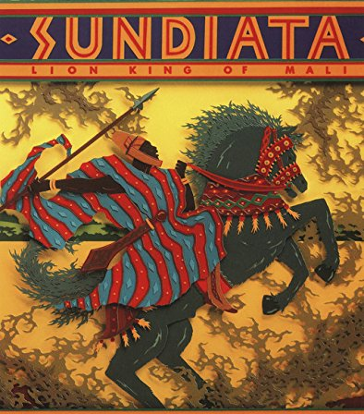
The decline of the Ghana Empire began with the rise of a Muslim people from the western Sahara, in the 11th century. Ghana was officially a pagan state, and the Muslims invaded to try to convert them. In 1076, Ghana came under Muslim control.
When the empire lost control over its gold trade, it began to decline. The region became instable. After many wars, a warrior named Sundiata conquered Ghana. The Empire of Ghana became the Empire of Mali.

