Cathedrals: In the Middle Ages, all western Europe was Roman Catholic. Entire communities united to build churches that would glorify religion and be a credit to their cities. It took many years and hundreds of people to construct the massive churches known as cathedrals. As a result, the buildings have stood for centuries. In many places, their roofs and spires still dominate the surrounding countryside. 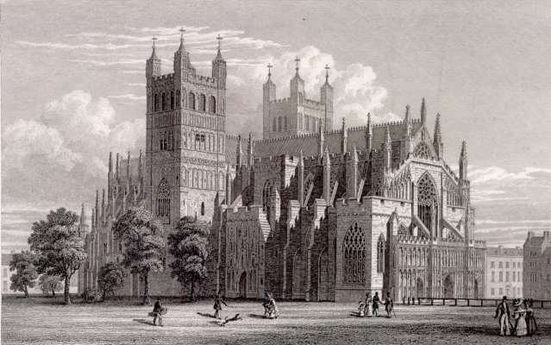
The most magnificent cathedrals were built mostly between the 12th and 15th centuries. Cathedrals in the Middle Ages were known for their tall pointed windows filled with pictures in stained glass. The light streamed in through these colorful windows, creating splendid patterns inside the cathedral.
To decorate these cathedrals, painters and sculptors created art to represent the history of humankind and of Christianity. Even worshippers who were unable to read could learn lessons from these scenes.
Illuminated Manuscripts: Illuminated manuscripts were handwritten books created by monks that have been decorated with gold, silver, brilliant colours, elaborate designs, and small pictures. The term “illuminated” refers to the decoration of books with gold, giving the impression that the page had its own light, or illumination.
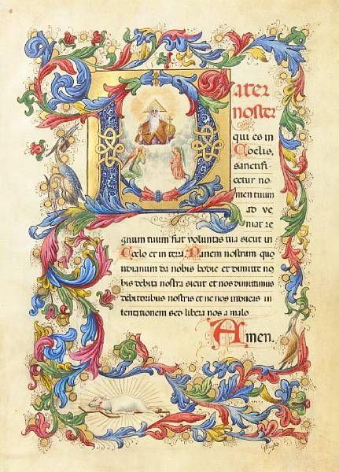
Though various Islamic societies also practiced this art, Europe had the longest tradition of illuminating manuscripts. However, after the development of printing in Europe in the second half of the 15th century, illumination was replaced by printed illustrations.

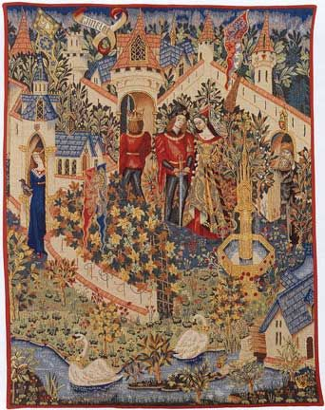
Tapestries: A tapestry is a heavy woven cloth with rich designs. During the Middle Ages, tapestries were often used to decorate castles and manor houses. Castles and stone manor houses were often very cold, and tapestries were hung on the walls to help keep the rooms warm.
Tapestries were often made of expensive materials such as silk, gold, and silver thread. It took many people to make a tapestry, and it was a difficult and time-consuming process. Only wealthy nobles could afford to own tapestries.
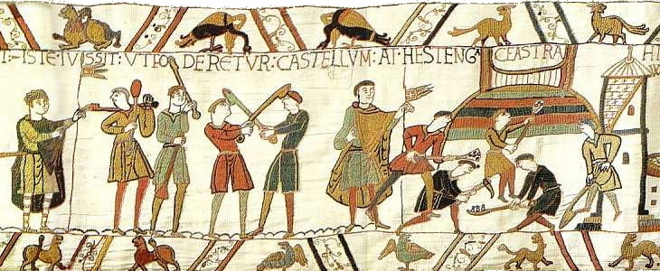
Though the earliest tapestries were very simple, by the late Middle Ages, tapestries were complex and ornate. They often told stories from the Bible, important events in history, and everyday castle life. Historians can tell a lot about daily life from the scenes in tapestries.

