The Middle Ages in Europe occurred between 500 and 1500 CE. The government of Rome had disappeared. It was replaced by thousands of small, regional governments, where the local lord was in charge. But the real ruler was the Catholic church. Religion dominated everything people did in their daily life. Each day began with worship. The Catholic church had enormous power. Religious leaders told the king and nobles, as well as the common people, what god wanted. Since people in the Middle Ages feared god, most of the time everyone from the king to a serf did what the church, through its religious leaders, told them to do.

Classes: There were three groups of people - the clergy, the nobles, and the commoners. The clergy included priests, bishops, cardinals, the Pope, and also friars, monks, and nuns. The nobles included kings, lords, and knights. And the commoners included the peasants and serfs.

Country Life: Until the rise of towns, most people lived on units called manors. Even after the rise of towns, many people stayed on the manors. Each manor included a village, the farmlands around the village, and the manor house, which was the home of the noble lord who protected the villagers in exchange for food, goods, and labor. The entire manor was owned by the noble.
The homes of serfs were usually one room huts, made of logs held together with mud, with thatched roofs. Homes had little furniture, perhaps a three-legged stool and beds made of straw covered with a leather toss. There were pegs on the walls to hold clothes. They usually had iron cooking pots and pans.
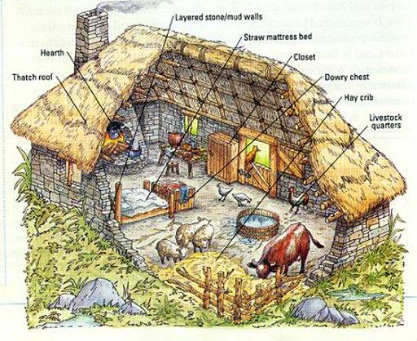
Town Life: Inside a wall surrounding a town, there were winding streets, and horse drawn carts piled high with goods to trade. Along each narrow street, there were little shops. Store owners lived above their shops. Shops were made of wood with thatched roofs. Fire was a constant worry.
As more and more people moved to the towns, and towns grew in size, towns began to stink. There was no plumbing in the towns. Garbage and sewage was tossed into the street. The only people who cleaned up and burned the garbage were the shop owners in the area who needed to keep the streets somewhat passable so that people could come to their shops. Much of the garbage stayed in the streets until it rotted. People got sick all the time. The living conditions were horrible.
Unless you had a shop of your own, with customers that paid their bills, you either worked for someone in exchange for food and shelter, or you begged. In spite of the conditions, more and more people arrived in the towns, eager to escape their life as serfs on the manors.
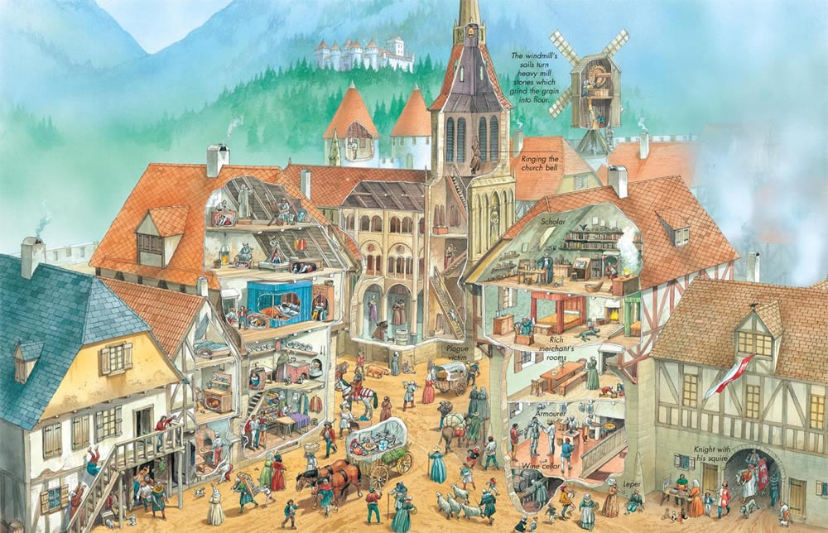
Whether you lived on a manor or in one of the growing towns, daily life in the Middle Ages was deeply religious and often violent.

Trade: The Crusaders returning from the Middle East and other places brought back with them new luxuries, food, and ideas. Independent merchants and traders made the oftentimes dangerous journey to gather these items.
A new kind of marketplace sprang up, a traveling market. These traveling markets would move from town to town. Merchants had to pay to set up their space. They had to rent their space from the local noble. They also usually had to pay a tax to the king to become a merchant at the fair. They would set up and stay for a week or two, selling what they had, then move to the next town.

