One of the most important of all institutions in the Middle Ages was the Roman Catholic Church. Throughout the Middle Ages the church was the center of arts, culture, and education.
The Clergy: The clergy are members of the church. In the Middle Ages the church was organized into different groups: the clergy, including the monks and the priests, and the laity (ordinary believers). Each of these groups was assigned specific functions by the church.

Education: In the Middle Ages, most people could not read or write. The church was responsible for public education. True, in the lords’ castles children went to their lessons, but noble boys were extremely few compared with the number of peasant boys. For the peasant boys, the church supplied schools and religious training.

Monks & Nuns: The work of the church was supported by the work of monks and nuns. Monks were men who studied the teachings of the church and lived in monasteries. Nuns were women who symbolically married Christ and lived in convents. Monks and nuns gave up earthly pleasures to serve God. They accepted a life of prayer and labor and upheld the Christian teaching of, “Love thy neighbor as thyself.” 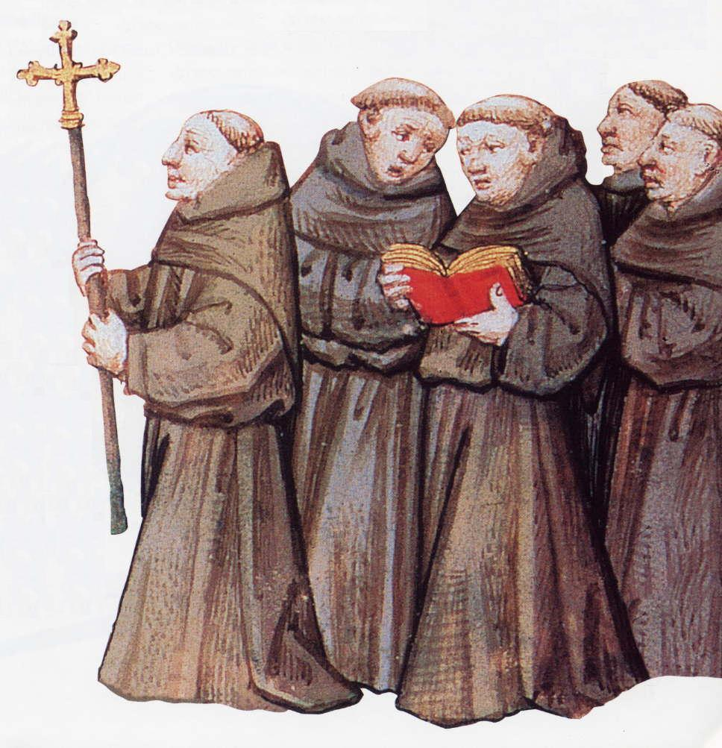
The monks had to do some manual labor, such as clearing forests, draining swamps, nursing the sick, sheltering travelers, and serving the needy. In this way, the monks provided important services to society in addition to their spiritual duties. Many people made donations to the monasteries so that the monks would pray for them.
Monks also spent hours in their writing rooms copying important documents and creating handwritten books. They wrote works of history, theology, poetry, law, and other disciplines.

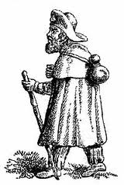
Pilgrimages and Crusades: People of all classes journeyed to holy sites on pilgrimages. Travel was difficult. Some people walked hundreds of miles along dangerous roads. The typical pilgrim could be identified by his cloak, walking stick, and wide-brimmed hat.
Every country had its own pilgrimages, but the great pilgrimage for all Christians was the Holy City, Jerusalem. The Holy Land had been held by Muslim Arabs for centuries, but Christian pilgrims had been allowed to travel there. When the Holy Land was invaded in the 11th century by Turks, they persecuted pilgrims.
Christians in Europe then promised to win the Holy Land from the Turks. Pope Urban II declared in 1095, “God wills it. Christ Himself will be your leader when you fight for Jerusalem.” On that command he sent forth European soldiers to fight a series of religious wars called the Crusades.
There were eight major crusades, but only the First Crusade truly succeeded in conquering Jerusalem. The Crusades lasted into the 16th century.
